BUT 1 – Semestre 2 – Saé 2.04 – English – Giorgio UTZERI – Mathys MULLIER

1)
a) First, we need to choose which CSV file will provide us with information about the applicants from 2006 to 2023.
We will use the file "UCAS June deadline 2023 - Age group.csv" because it defines the number of admitted applicants by age each year.
Next, we run a excel request for each year, such as:
=SOMME.SI.ENS(F:F; A:A; 2006)
This will calculate the number of applicants for the year 2006.
We then do this for each year up to 2023, and we get the following results:
5623990
5919590
6462830
7086660
7903150
8018010
7400760
7631280
7908670
8076820
8099150
7796840
7643920
7656750
7833770
8184470
8204140
8012160
We can then create the following graph :
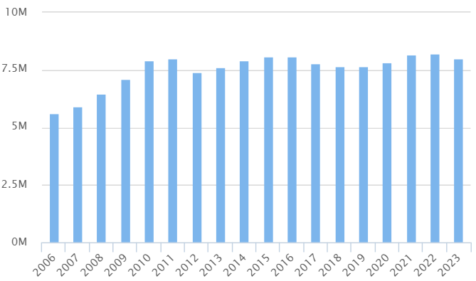

We notice an increase in the number of applicants from 2006 to 2011, followed by a plateau up to today in 2023.
b) To get the number of applicants from the EU, we will use the same file as in the previous question, but we will add a condition to the Excel query as follows:
=SOMME.SI.ENS(F:F; A:A; 2006; E:E; "=EU (excluding UK)")
This will exclude the calculation when column E is "EU (excluding UK)," meaning only those from the EU will be counted.
We then get the following results:
167480
187020
190730
220410
268480
283800
247450
258370
270590
291860
309350
293870
299000
301890
296140
168750
138930
134370
We can then create the following graph :
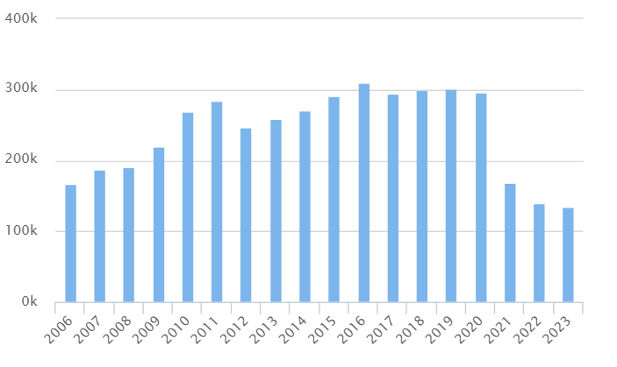
We can then see that this follows the trend from the previous question, with an increase until 2012. However, we also observe the impact of COVID and Brexit, with a decrease from 2021 to today.

c) To get the number of international applicants outside the EU, we will once again use the same method and the same file with the following query:
« =SOMME.SI.ENS(F:F; A:A; 2006; E:E; "=Not EU") »
We then get the following results:
245710
256060
279840
295650
325560
340450
368970
391090
416110
424910
417560
426730
454010
490170
536520
613680
670310
693940
We can then create the following graph :
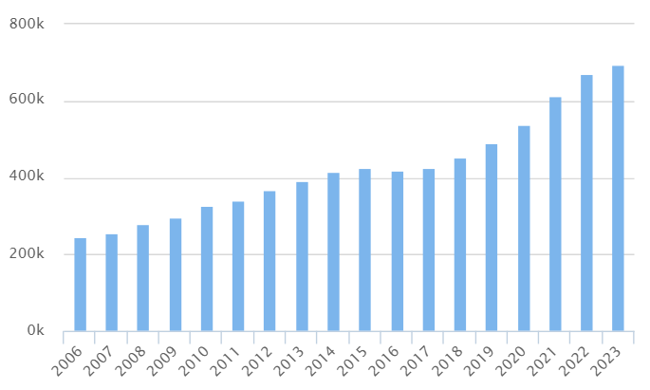
Here we notice, in contrast, a constant increase from 2006 up to today in 2023.

2) To compare the application figures between 2021 and 2023 for applicants from England, the EU (excluding the UK), Northern Ireland, international non-EU applicants, Scotland, and Wales, we will use the same file as in the previous question and create a table with the three years for the six categories. We will use the following query, modifying it for each piece of information:
« =SOMME.SI.ENS(F:F; A:A; 2021; E:E; "=England") »
We then get the following table:

 | England | EU (excluding UK) | Northern Ireland | Not EU | Scotland | Wales
2021 | 2737270 | 168750 | 116330 | 613680 | 316260 | 140020
2022 | 2753950 | 138930 | 110580 | 670310 | 287270 | 141130
2023 | 2679320 | 134370 | 105810 | 693940 | 264850 | 127930

We can then create the following graph :
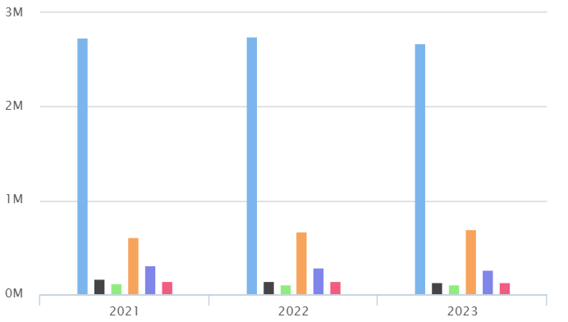
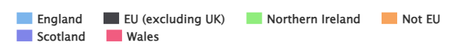
We then notice that most applicants come from England, which is quite logical, but we also see that the second largest group is not from neighboring countries or the EU. Instead, international non-EU applicants are the second largest group.

3) To answer the question of whether Brexit has had an effect on the number of French and Italian applicants to British universities, we will use the file "UCAS June deadline 2023 – Domicile.csv". This file will provide us with information about the applicants each year, including their countries of origin.

We will then conduct our research on two countries, France and Italy, using an Excel query: « =SOMME.SI.ENS(G:G; A:A; 2019; D:D; "=France") »
This will count the number of applicants from France in 2019. We repeat this process until 2021, and also for Italy.

We then get the following results:

 | France | Italy
2019 | 21350 | 17720
2020 | 20520 | 15770
2021 | 14420 | 9460
We can then create the following graph :
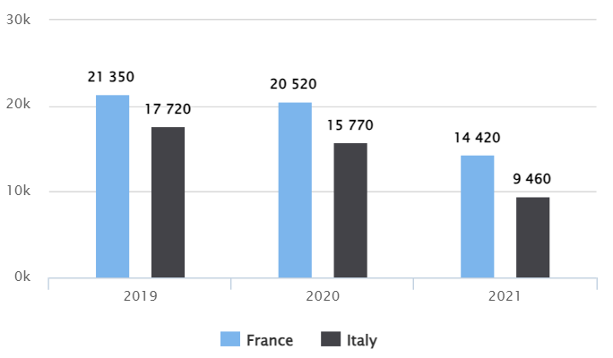
We then observe that Brexit has had an effect on the number of applicants from France and Italy, decreasing from 20,520 and 15,770 applicants to 14,420 and 9,460. However, this could also be explained by the COVID-19 pandemic.

4) To answer the question of determining which country (excluding the UK) recorded the highest number of applicants in June 2023, we need to use the file "UCAS June deadline 2023 – Domicile.csv".

To find the country with the highest number of applicants, we will look at which countries are present in the list and select the largest ones to then calculate the number of applicants.

We have therefore decided to keep the following countries:
France, Italy, Northern Ireland, Scotland, Netherlands, United States of America.

We then obtain the following data:
 | France | Italy | Northern Ireland | Scotland | Netherlands | USA
2023 | 11510 | 7180 | 70510 | 176530 | 2310 | 27600

We then notice that the country with the highest number of applicants in June 2023 is Scotland.

5) To answer the question of determining which country (excluding the UK) recorded the highest number of female applicants in June 2023, we will proceed in the same manner as the previous question using the file "UCAS June deadline 2023 – Domicile.csv". However, we will add the additional condition that the Gender must be "Female" in the calculations.

We then obtain the following results:

 | France | Italy | Northern Ireland | Scotland | Netherlands | USA
2023 | 3570 | 2090 | 21040 | 54420 | 630 | 9190

We can then observe that, as in the previous question, the country with the highest number of female applicants is Scotland.

6) To answer question 6, which asks to show how the number of applicants from Australia has evolved between 2006 and 2023, broken down by age groups and gender types, we will use the file "UCAS June deadline 2023 – Domicile.csv".

We will then use an Excel query to obtain the number of applicants for Australia for each year from 2006 to 2023, repeating the process for different gender and age groups.
This will give us the following table:
Australia | Applicants | Female | Male | 17 and under | 18 | 19 | 20
2006 | 1410 | 370 | 340 | 20 | 280 | 140 | 100
2007 | 1500 | 400 | 360 | 40 | 280 | 180 | 90
2008 | 1720 | 480 | 390 | 40 | 300 | 210 | 100
2009 | 1790 | 440 | 450 | 20 | 320 | 280 | 120
2010 | 1960 | 530 | 450 | 40 | 320 | 300 | 130
2011 | 2270 | 600 | 550 | 50 | 400 | 260 | 190
2012 | 2220 | 670 | 460 | 50 | 490 | 290 | 140
2013 | 2290 | 620 | 530 | 50 | 460 | 360 | 140
2014 | 2360 | 680 | 490 | 60 | 480 | 310 | 200
2015 | 2480 | 720 | 520 | 60 | 500 | 340 | 160
2016 | 2580 | 730 | 570 | 70 | 500 | 380 | 140
2017 | 2330 | 630 | 540 | 60 | 410 | 360 | 180
2018 | 2450 | 680 | 530 | 50 | 480 | 320 | 180
2019 | 2420 | 700 | 510 | 60 | 480 | 380 | 130
2020 | 2160 | 580 | 500 | 40 | 440 | 320 | 160
2021 | 1600 | 480 | 330 | 70 | 360 | 190 | 80
2022 | 1390 | 400 | 300 | 40 | 320 | 190 | 60
2023 | 1340 | 380 | 290 | 40 | 320 | 180 | 80

Which we can then convert into a graph :
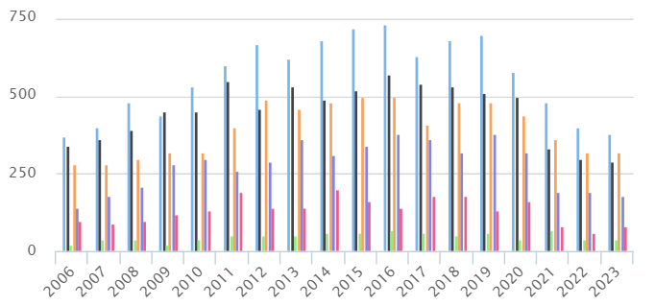

We then notice that there are more girls coming from Australia, and the most common age group is 18 years old.

7) To show how the number of applicants from China has evolved between 2006 and 2023, we will proceed in the same way by performing the same calculations and creating the same diagrams. To do this, we just need to modify the value "Austria" to "China" in the Excel query, which gives us the following query:
« =SOMME.SI.ENS(G:G; A:A; I11; D:D; "=China") »

We then do this for all the following characteristics: female, male, 17 and under, 18, 19, and 20, which gives us the following table:

China | Applicants | Female | Male | 17 and under | 18 | 19 | 20
2006 | 21350 | 5430 | 5250 | 220 | 1680 | 3440 | 2590
2007 | 23740 | 6010 | 5850 | 270 | 2240 | 4000 | 2890
2008 | 28760 | 7370 | 7010 | 300 | 2640 | 4920 | 3660
2009 | 30720 | 8060 | 7300 | 330 | 2640 | 4840 | 4240
2010 | 34000 | 9050 | 7950 | 400 | 3060 | 4860 | 4600
2011 | 38650 | 10630 | 8700 | 580 | 3680 | 5380 | 4470
2012 | 42070 | 11510 | 9530 | 790 | 4190 | 5920 | 4780
2013 | 42760 | 12010 | 9360 | 920 | 5290 | 6160 | 4820
2014 | 42940 | 12020 | 9450 | 1140 | 5520 | 6620 | 4460
2015 | 46150 | 13430 | 9650 | 1260 | 6640 | 7120 | 4480
2016 | 49810 | 14480 | 10420 | 1580 | 7860 | 7500 | 4560
2017 | 53570 | 15430 | 11340 | 1710 | 8700 | 8410 | 4660
2018 | 60990 | 17590 | 12900 | 2130 | 11520 | 8670 | 4680
2019 | 79040 | 22110 | 17400 | 2310 | 16180 | 12020 | 5260
2020 | 97690 | 26850 | 21990 | 3160 | 19840 | 14700 | 6860
2021 | 113990 | 29780 | 27220 | 3300 | 25740 | 16000 | 7490
2022 | 125630 | 32840 | 29980 | 4780 | 29820 | 15060 | 7770
2023 | 122820 | 31790 | 29630 | 3260 | 30000 | 15940 | 6730

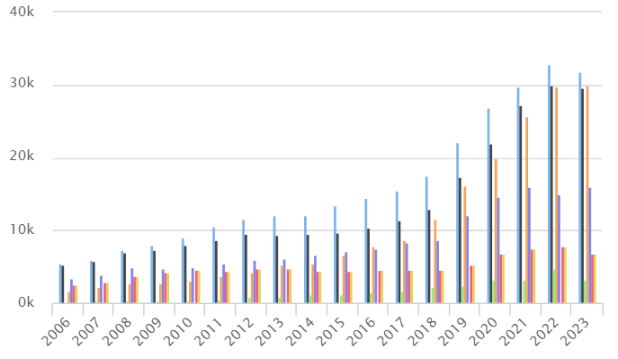
We can then ask the software to convert this table into a graphical representation, and we obtain the following:
We can then observe on this graph a constant increase since 2006 with no decrease in any year.
We also notice that the ratio of girls to boys was quite balanced until 2012, but from 2012 to 2023, the ratio of girls is much higher than that of boys.
Additionally, the most common age group was 19 years old until 2015, but from 2015 to 2023, the most common age group is 18 years old, with nearly double the number of applicants in 2023.

